# Leaf Controller

We will call Leaf Controller to the Linux System (BananaPi-R2 or ExpressoBin-Ultra or ModBerry) plus the Controllino-Mega:

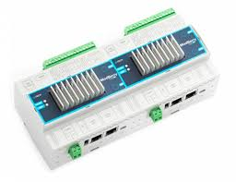

ModBerry

EspressoBin-Ultra

BananaPi-R2

Controllino-Mega

**Linux System**

BananaPi-R2

EspressoBin-Ultra

ModBerry

Controllino-Mega

Ethernet

USB

Creating a Linux SDcard for BananaPi R2

For this purpose, balenaEtcher software can be used, <https://www.balena.io/etcher/>

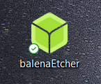

The file to be used is **fluence_202111221625_master.img.gz**.

# qModMaster communication with Controllino

qModMaster (unzip qModMaster-Win64-exe-0.5.3-beta.zip, executable qModMaster.exe, https://sourceforge.net/projects/qmodmaster/) can be used to dialog to the Controllino through the Ethernet interface.

1. Configure the Windows laptop to have address 192.168.2.10

1. Connect a direct Ethernet cable between the Windows laptop and the Controllino
2. The Controllino has address 192.168.2.3 port 502, so in QModMaster select “Options | Modbus TCP…” and set

1. Use qModMaster to write Outputs and read Inputs, using Unit ID 42, and the proper Modbus Function Code.

qModMaster Start address is 1, whereas in the LeafController Linux-Python is 0!

# qModMaster communication with the LeafController Linux-Python

In order to communicate directly with the LeafController Linux-Python:

1. Configure the Windows laptop to have address 192.168.2.10

1. Graphical user interface, application

   Description automatically generatedPerform a loopback connection to the Windows laptop on address 192.168.2.10 port 1502, so in QModMaster select “Options | Modbus TCP…” and set
2. Use qModMaster to read Input Registers, using Unit ID 42, and the proper Modbus Function Code.

qModMaster Start address is 1, whereas in the LeafController Linux-Python is 0!

So, to read the variables in controllino_controllino.py:

['aggTripAlarmCore', 0x182A, 0xAB, 'ro', 'v'], # address 6186

['aggTripAlarmCube', 0x182B, 0xBA, 'ro', 'v'] # address 6187